Porosity, Permeability, Capillarity & Retention

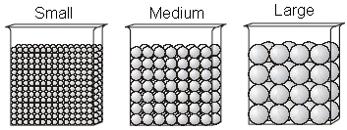
Permeability is the ability of water to enter the ground. If the ground is impermeable, then water cannot enter and is forced to run off. If the ground is already saturated (full of water) for example, it may be impermeable to more water.

Notice the three containers with uniform
sediments. We learned before that the porosity
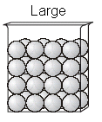
of all three is equal (lots of small spaces in the
Infiltrating water
first equals fewer big space in the last). What
about the ability of water to enter though?

Large particles have more space between, making it easier for water to
enter. Small particles are less permeable, since water has a hard time entering.

BTW…easy in easy out! In other words, if water can infiltrate quickly, it
can also drain (leave) quickly. This is measured as retention. Small particles
have a greater retention rate than large particles (i.e., water takes longer to drain).

Finally, water will stick to sediments (doesn’t a bathing suit stay wet for a
while?). This is called adhesion. In fact, water is so attracted to sediments
(like iron to a magnet) that it actually moves up to reach them sometimes! This is referred to as capillarity.

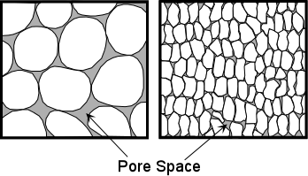
- Which sample to the right:
A
B
- is the most permeable? _________
- can water infiltrate the fastest? ________
- has the greatest retention rate? ________
- has the greatest capillarity? ________

- The columns to the left are filled with uniform plastic beads of two different sizes. Which statement best describes the water retention and permeability in the columns of beads?

(1) The column with 4-mm beads has greater
water retention and permeability.
(2) The column with 12-mm beads has greater
water retention and permeability.
(3) The column with 4-mm beads has greater
water retention & the column with 12-mm
beads has greater permeability.
(4) The column with 12-mm beads has greater
water retention & the column with 4-mm
beads has greater permeability.
- Finish the sentence: As the size of a particle increases, its permeability to water ___________________.

- A soil sample with a large amount of space between the particles will have a

(1) low permeability rate (2) low infiltration rate (3) high porosity (4) high capillarity

- The diagram to the right shows an experiment where soil of different size particles is allowed to come into contact with water.
Results of this experiment lead to the conclusion that

(1) capillarity is greater in soils with
larger particles
(2) capillarity is greater in soils with
smaller particles
(3) permeability is greater in soils with larger particles
(4) permeability is greater in soils with smaller particles

- The diagram right shows two identical containers filled with uniform particles that were sorted by size.
Which characteristic is most likely the same for these particle filled containers?

(1) infiltration rate (3) capillarity
(2) water retention (4) porosity

- Which soil conditions normally result in the greatest amount of runoff?

(1) low permeability and gentle slope (3) high permeability and gentle slope
(2) low permeability and steep slope (4) high permeability and steep slope

- Which graph shows the effect of soil permeability on the amount of runoff in an area?

- In which column of sediment will capillary action cause water from a beaker to rise fastest?

(1) a column with small pebbles (3) a column with medium sand
(2) a column with large sand (4) a column with large silt

- From which plastic column of sediment will water drain the fastest?

(1) a column with small pebbles (3) a column with medium sand
(2) a column with large sand (4) a column with large silt

